**Engineering Thermodynamics**

**Tutorial-2 Properties of pure substances**

1. Fill out the following table for water
   1. p=500 kPa, T= 20 C. find v, x (b) p=500 kPa, v=0.2 m3/kg. Find T, x (c) p=1400 kPa, T=200. Find v, x (d) T=300, x=0.8. Find v, p. Show the states on p – v or T – v diagrams.
2. A sealed rigid vessel has volume of 1 m3 and contains 2 kg of water at 100 °C. The vessel is now heated. If a safety pressure valve is installed, at what pressure should the valve be set to have a maximum temperature of 200 °C?
3. Saturated water vapor at 200 kPa is in a constant pressure piston cylinder. At this state the piston is 0.1 m from the cylinder bottom. How much is this distance and the temperature if the water is cooled to occupy half the original volume?x2=0.4994
4. Water vapour is heated in a closed rigid tank from saturated vapour at 160 oC to a final temperature of 400 oC. determine the initial and final pressures, in bar, and sketch the processes on T-v and p-v diagrams. 617.7, 998.4 kPa
5. A piston/cylinder arrangement is loaded with a linear spring and the outside atmosphere. It contains water at 5 MPa, 400°C with the volume being 0.1 m3. If the piston is at the bottom, the spring exerts a force such that Plift = 200 kPa. The system now cools until the pressure reaches 1200 kPa. Find the mass of water, the final state (T2, v2) and plot the P–v diagram for the process. x2=0.06724
6. A cylinder/piston arrangement contains water at 105°C, 85% quality with a volume of 1 L. The system is heated, causing the piston to rise and encounter a linear spring as shown in Fig. At this point the volume is 1.5 L, piston diameter is 150 mm, and the spring constant is 100 N/mm. The heating continues, so the piston compresses the spring. What is the cylinder temperature when the pressure reaches 200 kPa? 641.6 oC
7. A piston/cylinder contains 1 kg water at 20 oC with volume 0.1 m3. By mistake someone locks the piston preventing it from moving while we heat the water to saturated vapor. Find the final temperature, volume and the process work.212.2 oC, 0.1 m3
8. A piston/cylinder contains 1 kg of liquid water at 20°C and 300 kPa. Initially the piston floats, with a maximum enclosed volume of 0.002 m3 if the piston touches the stops. Now heat is added so a final pressure of 600 kPa is reached. Find the final volume and the work in the process. 0.3 kJ
9. A bottle with a volume of 0.1 m3 contains butane with a quality of 75% and a temperature of 300 K. Estimate the total butane mass in the bottle using the generalized compressibility chart.
10. A mass of 2 kg of acetylene is in a 0.045 m3 rigid container at a pressure of 4.3 MPa. Use the generalized charts to estimate the temperature.
11. A 500-L tank stores 100 kg of nitrogen gas at 150 K. To design the tank the pressure must be estimated and three different methods are suggested. Which is the most accurate and how different in percent are the other two? (a) Ideal gas (b) Generalized compressibility chart.

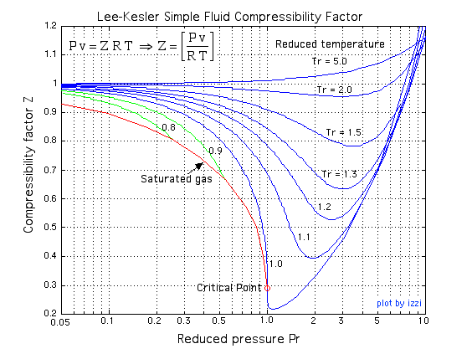

<http://www.ohio.edu/mechanical/thermo/property_tables/gas/Zfactor.html>